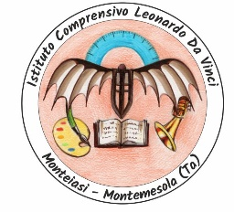
Istituto Comprensivo Statale Leonardo da Vinci
Monteiasi / Montemesola (Taranto)

THE APULIAN UNESCO SITES

LESSON PLAN - UNESCO SITES IN APULIA
Last year, exactly when the school year began, our school planned to focus its attention on environment protection in general and on respect of the cultural heritage. So we decided to join these aims to the main aim of our “Young Historians of Europe” Erasmus project: to disseminate the own cultural heritage as well as Unesco sites.
We will start with the importance of Unesco in the world to move to our sites in Italy and then in Apulia, where we live. The Apulian Unesco sites are four:
- Alberobello (Bari)
- Castel del Monte (BAT)
- Monte Sant’Angelo (Foggia)
- Foresta Umbra (Foggia)
Our students will do historical and geographical research on various places, collect photos and create a map for tourists.
As a culminating activity, the students will describe all these places and indicate how to reach them as tour guides.

LEARNING OBJECTIVES

Upon completion of this lesson, students will be able to:
- To know the Unesco’s objectives
- To know and describe the four Apulia Unesco sites
- Explain their historical and geographic significance

ASSESSMENT
- The class will be divided into groups, assigning each group a specific area in general. Each group will explore its assigned area and then create a brochure to give information on that particular area

- As a whole class, will be assigned to students to write an essay or a ppt on their favourite place.

- On May the students will visit Alberobello and Castel del Monte taking notes and exchanging information with their classmates.

